Different formulations of Kalman Filter

* Modeling

And

1. Two states

%% Speyer, page 97 %%

* 1. states
  2. Prediction(priori)
  3. Updating (Estimation, Posterior)
  4. Kalman Gain

1. Three states

%% <https://en.wikipedia.org/wiki/Kalman_filter> %%

* 1. Three states
  2. Prediction
  3. Innovation %%”Speyer,page 98”
  4. Kalman Gain
  5. Updating

%%% HW Supp_1.1

Prove the kalman gain are equivalent to each case i.e., two state and three state %%

%% Kim’s Comment

1. Two and three states formula are the same to Kalman Gain, but for the numerical stability , three states are preferable.
2. In the three state system models, it is not the minimal realization.
3. 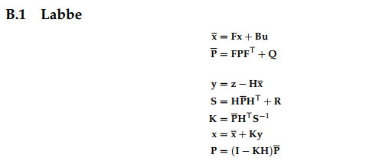There are many notation variances. ”Kalman and Bayesian Filters in Python, 2018”

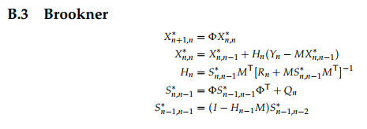

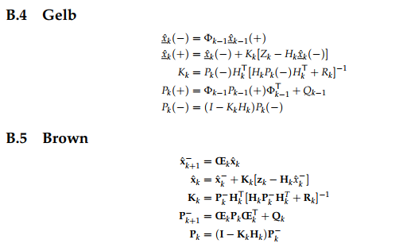

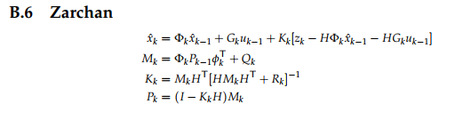

1. In the book of .”Kalman and Bayesian Filters in Python, 2018”, there are many filters as

* Kalman filter
* Unscented Kalman filter
* Extended Kalman filter
* Particle filter
* Ensemble Kalman filter
* “H infinity” filter

So which one is the best? “There is no royal road” It depends on your modeling. After invention computers, the computation power is no limited. So if you image something new algorithm, it may be realizable. These filters are difficult to achieve without “Computer” ,

* The importance of estimators

1) linear system

The estimator design is important. In linear system, the PID is basically output feed back, which means the closed poles are confined in some points even if you design PID in any sense !!! (Think about root locus). However, if the state feedback is allowed, you may assign the closed loop poles at any places in the RHP! How to achieve state feedback? The only method is to estimate all the states using only measured output data.

2) non-linear system

It is more important . It is difficult to design PID due to the non-linearity. Linearization needs to estimator of the states. To apply the sliding mode / bi-linear … , you may need the estimator.

3) Nowadays the estimator is more important not only in control but in data science, machine learning . There should be “Estimation” to be optimal in the sense.